Conjugate Heat Transfer Simulation Report
Electronic Component Assembly Cooling Optimization
SolidWorks Flow Simulation Study

Prepared for: Engineering simulation documentation and design review
Study focus: Internal forced convection CHT, fan configuration selection, heat sink optimization, and power block cooling
Final selected design: Optimized aluminum heat sink with side-mounted cross-flow inlet fan
Image references: Every figure caption includes the source image file name from the uploaded image set.

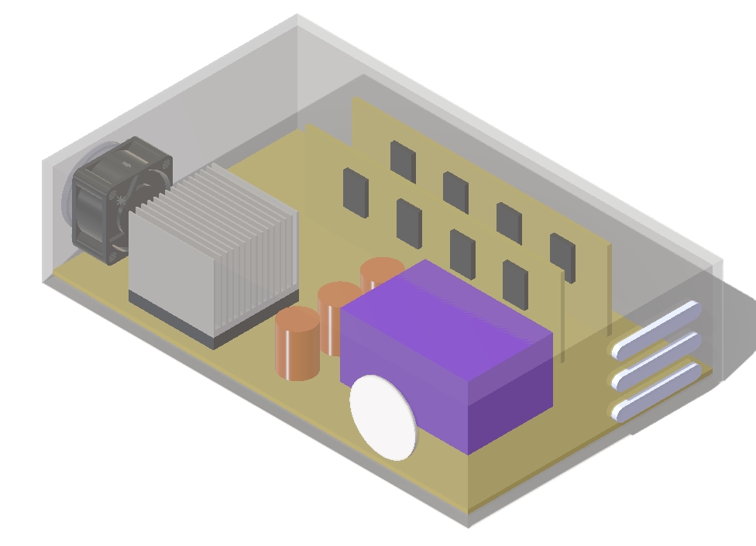
Figure 1. Final optimized design geometry with optimized heat sink and cross-flow fan. Image file: case08_cross_fan_geometry.png

Executive Summary
This report documents a conjugate heat transfer (CHT) simulation study of an electronic component assembly in SolidWorks Flow Simulation. The study began with a simple external inlet fan baseline and progressed through fan configuration comparisons, high-power stress cases, passive venting, exhaust fan testing, heat sink optimization, and final balancing with a cross-flow inlet fan. The primary objective was to reduce the main chip temperature while keeping the power block and smaller components within acceptable limits.
The final balanced configuration was Case 08: optimized aluminum heat sink with a side-mounted cross-flow inlet fan. This design kept the main chip at 61.07 °C and the power block at 59.96 °C under the 25 W chip / 10 W power block condition. The final design avoided the dust-risk strategy of adding uncontrolled top vents, while also avoiding the poor chip-cooling behavior observed with the rear exhaust fan case.
Metric | Case 04B Internal Fan Stress | Case 07 Optimized HS | Case 08 Final Balanced Design
Main chip max temperature | 99.80 °C | 50.89 °C | 61.07 °C
Power block max temperature | 65.15 °C | 84.10 °C | 59.96 °C
Heat sink average temperature | 98.16 °C | 48.12 °C | 58.00 °C
Maximum fluid temperature | 99.79 °C | 84.09 °C | 61.07 °C
Outlet average temperature | 38.21 °C | 38.76 °C | 33.10 °C
Outlet mass flow | -0.00231 kg/s | -0.00227 kg/s | -0.00390 kg/s
Correct chip thermal resistance | 2.99 °C/W | 1.04 °C/W | 1.44 °C/W
Key conclusion: the dominant design challenge was not simply increasing total airflow. The simulations showed that airflow had to be delivered to the right thermal regions. The optimized heat sink solved the main chip temperature but created a power block hot spot. The cross-flow inlet fan then solved that secondary hot spot and produced the best balanced result.

Report Structure
1. Simulation setup and assumptions
2. Case matrix and numerical comparison
3. Detailed case results with image references
4. Final design decision
5. Limitations
6. Future optimization for higher wattage
7. Image reference appendix

1. Simulation Setup and Assumptions

Simulation objective
The objective was to evaluate the thermal performance of an electronic component assembly under forced convection using conjugate heat transfer. The model included solid heat conduction through the chip, heat sink, board, enclosure, and power block, coupled with internal air flow through the enclosure.

General model setup
Category | Baseline / Study Setting
Analysis type | Internal flow with heat conduction in solids enabled
Fluid | Air
Ambient condition | 25 °C, 101325 Pa at environmental openings
Outer wall thermal condition | External convection approximation, 5 W/m²·K to 25 °C ambient
Radiation | Neglected for this study
Gravity | Off for forced-convection comparison
Primary fan family | Sunon GM0535PFV1-8 fan curve from SolidWorks fan database
Nominal fan size context | 35 mm fan class matched to the approximately 36 mm fan in the assembly

Material assumptions
Part | Material used
Heat sink | Aluminum 6061 for most cases; copper was tested and later removed from the main case list due minimal benefit
Optimized heat sink | Aluminum, 50 x 50 mm footprint, 40 mm height, 1 mm fins, 14 fins, 3.3 mm fin gap, 3.5 mm base
Main motherboard and vertical PCBs | FR-4
Main chip and small chips | Silicon simplification
Power block | Aluminum 6061 simplified block
Enclosure | Polycarbonate, after ABS was not available in the material database
Capacitors | Aluminum simplification

Heat load assumptions
Condition | Main chip | Power block | Small chips
Initial low-power comparison | 10 W | 5 W | 0.5 W each
Higher-power stress and optimization cases | 25 W | 10 W | 0.5 W each
Note: thermal resistance values in this report use the active main chip heat load for each case. For example, 10 W cases use (Tchip - 25)/10 and 25 W cases use (Tchip - 25)/25. This avoids the earlier issue of an equation goal being hardcoded for 10 W.

2. Case Matrix and Numerical Comparison
Case | Configuration | Chip / Power Block Load | Main Chip Max (°C) | Power Block Max (°C) | Key Decision
01 | External inlet fan baseline | 10 W / 5 W | 57.39 | 48.95 | Reference case
02 | External inlet fan + reducer shroud | 10 W / 5 W | 48.33 | 51.11 | Strong chip cooling, packaging/space tradeoff
03 | External outlet fan | 10 W / 5 W | 118.78 | 75.14 | Rejected: poor heat sink cooling
04 | Internal fan | 10 W / 5 W | 50.87 | 41.72 | Selected fan modeling approach
04B | Internal fan stress case | 25 W / 10 W | 99.80 | 65.15 | Too hot for chip
05 | Internal fan + upper vent | 25 W / 10 W | 84.37 | 55.25 | Thermally good, rejected due dust/opening concern
06 | Internal fan + rear exhaust fan | 25 W / 10 W | 95.40 | 58.48 | Rejected: worsened chip cooling
07 | Optimized aluminum heat sink | 25 W / 10 W | 50.89 | 84.10 | Chip fixed, power block became limiting
08 | Optimized heat sink + cross-flow inlet fan | 25 W / 10 W | 61.07 | 59.96 | Best balanced design

Detailed numerical results
Case | Main Chip Max | Chip Avg | Heat Sink Avg | Power Block Max | Small Chips Max | Max Fluid | Outlet Avg | Fan/Outlet Mass Flow
01 Baseline | 57.39 °C | 57.14 °C | 56.84 °C | 48.95 °C | 31.72 °C | 57.38 °C | 29.68 °C | +0.00306 / -0.00306 kg/s
02 Shroud | 48.33 °C | 48.05 °C | 47.76 °C | 51.11 °C | 31.51 °C | 51.10 °C | 30.79 °C | +0.00234 / -0.00234 kg/s
03 Outlet Fan | 118.78 °C | 118.46 °C | 118.14 °C | 75.14 °C | 29.83 °C | 118.78 °C | 29.90 °C | ~0.00269 kg/s
04 Internal Fan | 50.87 °C | 50.59 °C | 50.28 °C | 41.72 °C | 35.09 °C | 50.87 °C | 29.61 °C | +0.00294 / -0.00294 kg/s
04B 25 W Stress | 99.80 °C | 98.95 °C | 98.16 °C | 65.15 °C | 45.63 °C | 99.79 °C | 38.21 °C | +0.00231 / -0.00231 kg/s
05 Upper Vent | 84.37 °C | 83.75 °C | 82.98 °C | 55.25 °C | 38.09 °C | 84.35 °C | 32.55 °C | +0.00379 kg/s fan
06 Rear Exhaust | 95.40 °C | 94.70 °C | 93.90 °C | 58.48 °C | 40.64 °C | 95.37 °C | 36.48 °C | +0.00278 kg/s main, -0.00272 exhaust
07 Optimized HS | 50.89 °C | 50.36 °C | 48.12 °C | 84.10 °C | 39.81 °C | 84.09 °C | 38.76 °C | +0.00227 / -0.00227 kg/s
08 Final | 61.07 °C | 60.25 °C | 58.00 °C | 59.96 °C | 38.44 °C | 61.07 °C | 33.10 °C | +0.00157 main, -0.00390 outlet kg/s
The comparison shows that the external outlet fan and rear exhaust fan cases were not selected because they worsened chip cooling. The upper vent case met the chip target but was not selected because additional uncontrolled openings can increase dust ingress. The optimized heat sink strongly cooled the chip but shifted the limiting temperature to the power block. The final cross-flow fan case balanced both major heat sources.

3. Detailed Case Results and Image References

Case 01: External Inlet Fan Baseline
Case 01 used an external inlet fan pushing air into the enclosure with the existing rear outlet vents modeled as environmental pressure openings. This case established the original low-power reference at 10 W chip and 5 W power block.
Metric | Value
Main chip max temperature | 57.39 °C
Power block max temperature | 48.95 °C
Heat sink average temperature | 56.84 °C
Fan mass flow | +0.00306 kg/s
Decision | Reference case
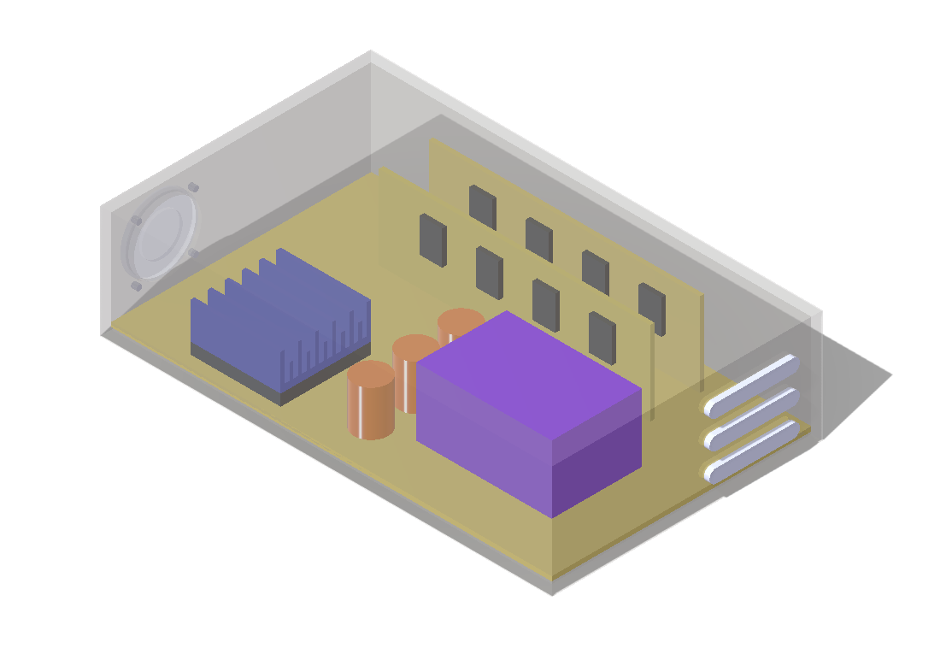
Figure 2. Case 01 baseline assembly geometry. Image file: case01_baseline_geometry.png
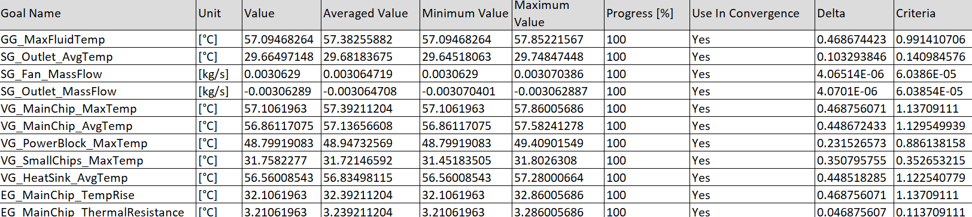
Figure 3. Case 01 goal table with convergence and averaged values. Image file: case01_baseline_goal_table.png
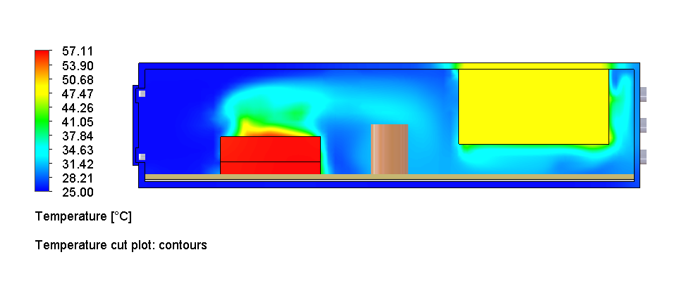
Figure 4. Case 01 temperature cut plot showing the main chip and heat sink hot region. Image file: case01_baseline_temperature_cut.png
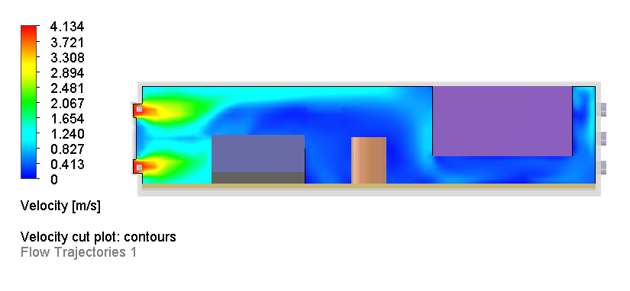
Figure 5. Case 01 velocity cut plot showing inlet flow and low-velocity regions. Image file: case01_baseline_velocity_cut.png
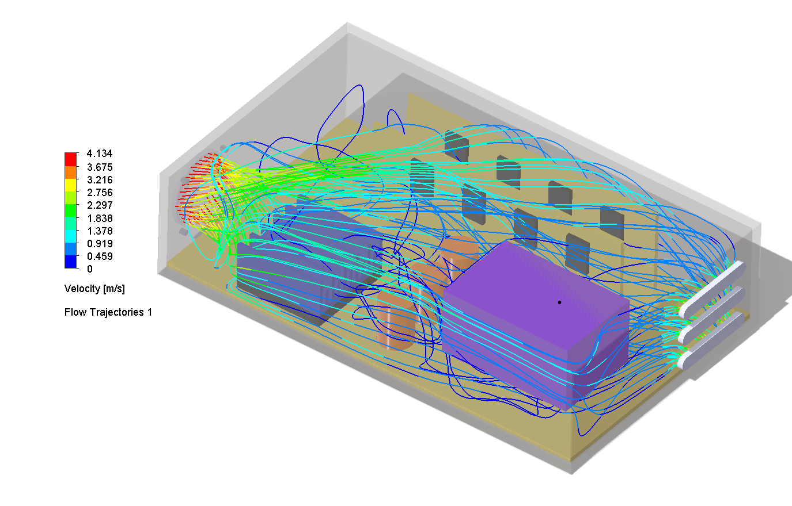
Figure 6. Case 01 flow trajectories showing 3D airflow path from the fan. Image file: case01_baseline_flow_trajectories.png
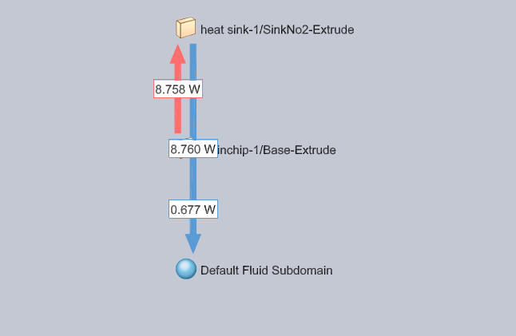
Figure 7. Case 01 heat flow budget from main chip into heat sink and fluid. Image file: case01_baseline_heat_flow_budget.png
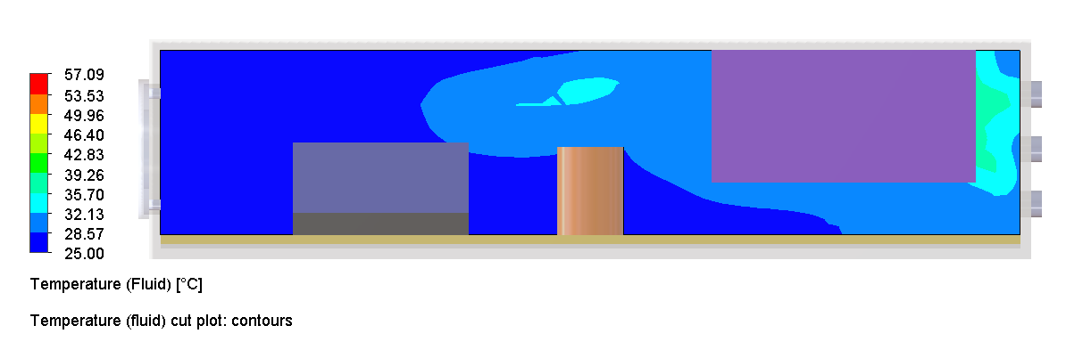
Figure 8. Case 01 fluid temperature cut plot. Image file: case01_baseline_fluid_temperature.png

Case 02: External Inlet Fan with Reducer Shroud
Case 02 added a reducer shroud between the external inlet fan and heat sink. The shroud reduced bypass flow and improved targeted heat sink cooling at the 10 W chip load, but it was not selected as the main direction due packaging space and the later decision to use an internal fan model.
Metric | Value
Main chip max temperature | 48.33 °C
Power block max temperature | 51.11 °C
Heat sink average temperature | 47.76 °C
Fan mass flow | +0.00234 kg/s
Decision | Strong chip cooling, retained as airflow-guidance evidence
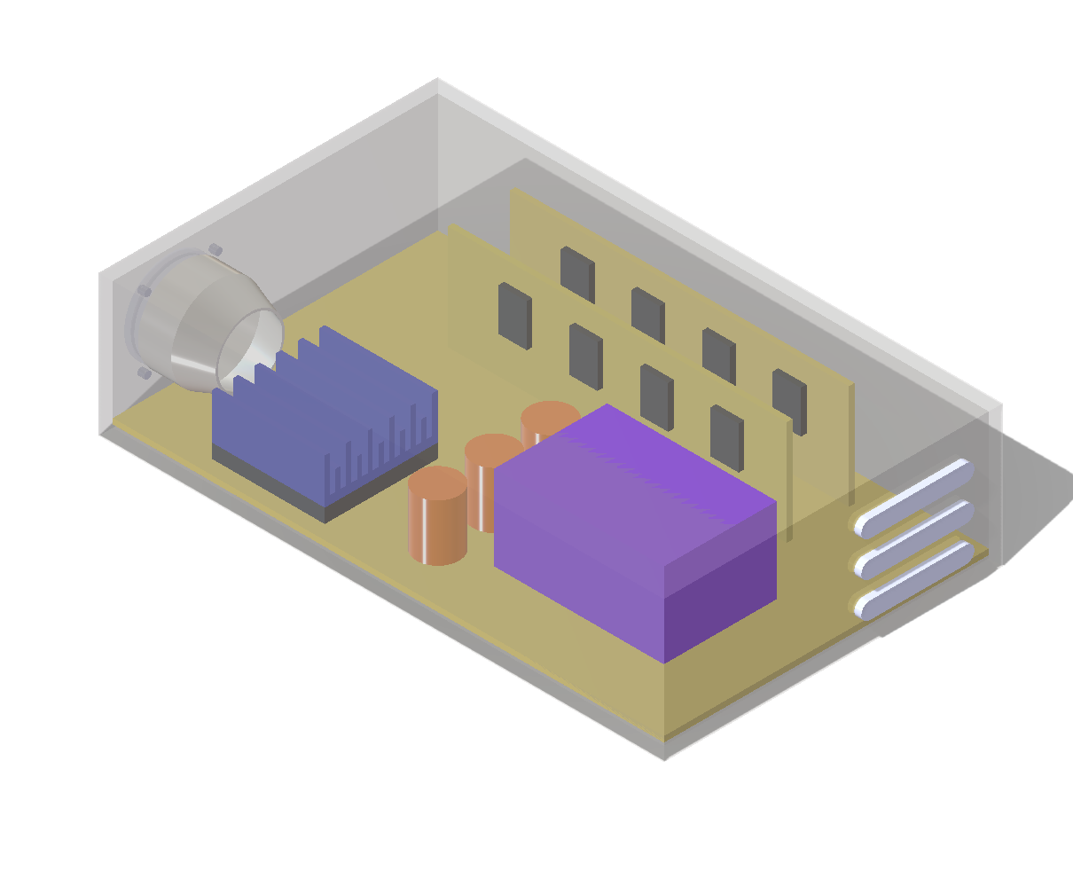
Figure 9. Case 02 geometry with reducer shroud. Image file: case02_reducer_shroud_geometry.png
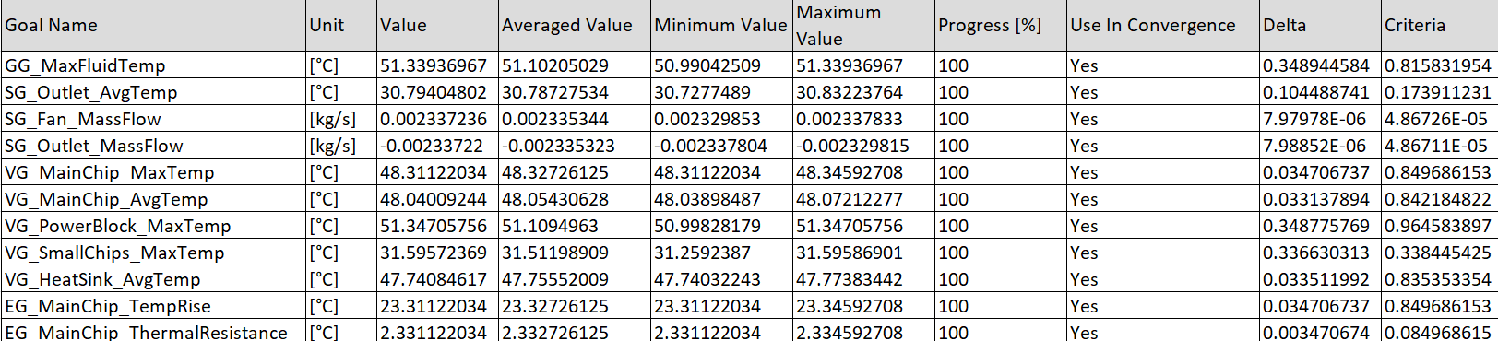
Figure 10. Case 02 goal table with improved chip temperature. Image file: case02_reducer_shroud_goal_table.png
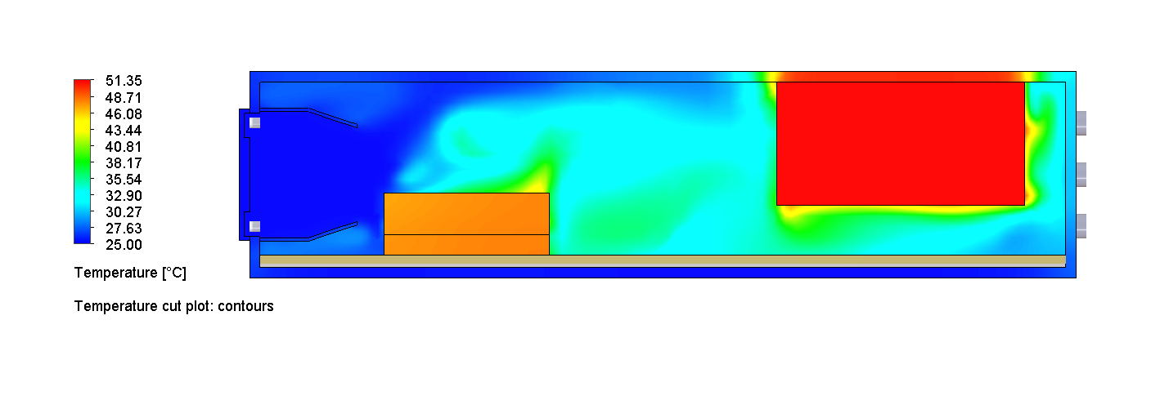
Figure 11. Case 02 temperature cut plot. Image file: case02_reducer_shroud_temperature_cut.png
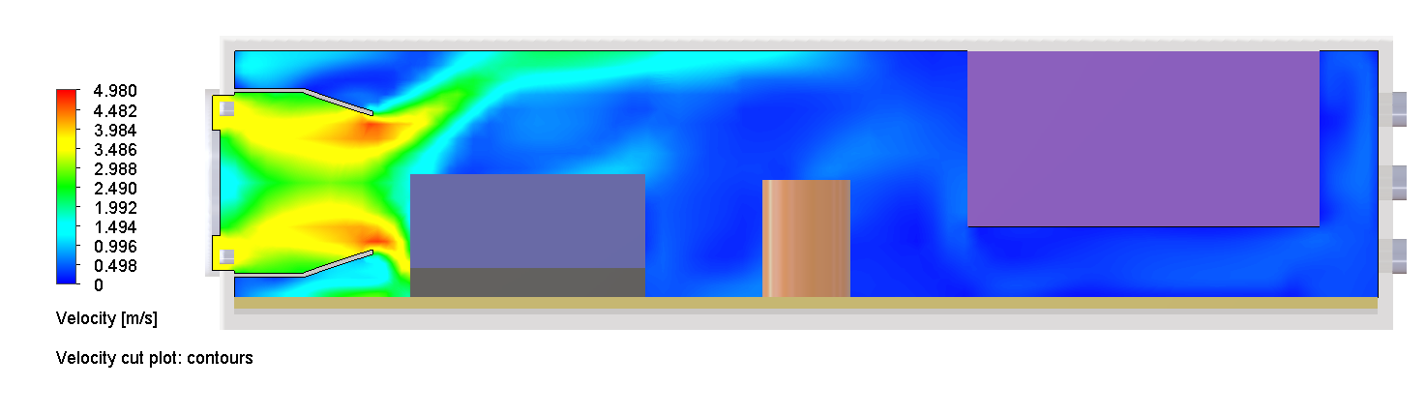
Figure 12. Case 02 velocity cut plot showing guided airflow. Image file: case02_reducer_shroud_velocity_cut.png
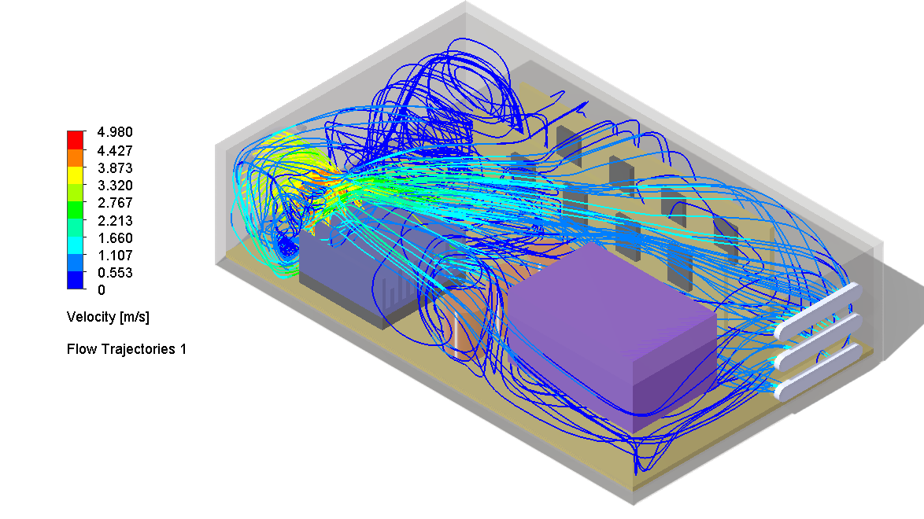
Figure 13. Case 02 flow trajectories with reducer shroud. Image file: case02_reducer_shroud_flow_trajectories.png
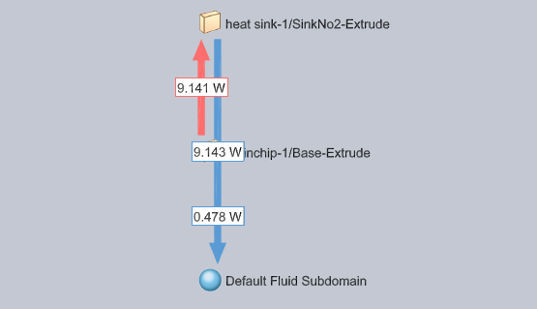
Figure 14. Case 02 heat flow budget showing increased chip-to-heat-sink transfer. Image file: case02_reducer_shroud_heat_flow_budget.png
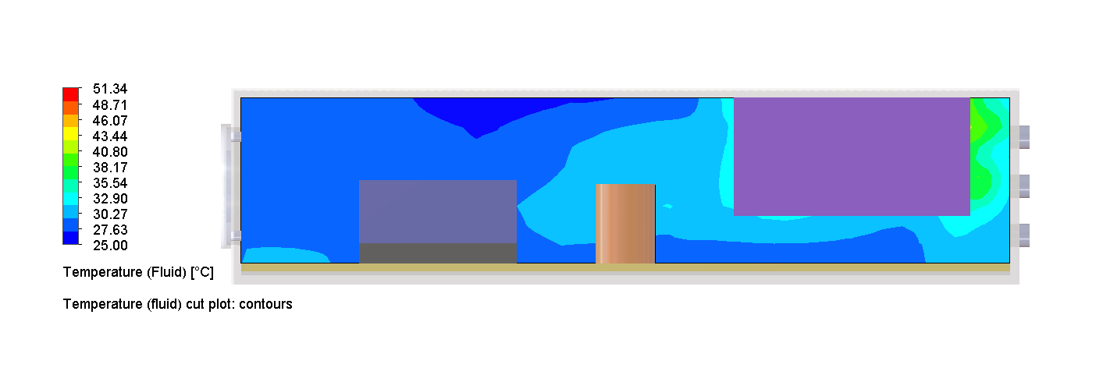
Figure 15. Case 02 fluid temperature cut plot. Image file: case02_reducer_shroud_fluid_temperature.png

Case 03: External Outlet Fan
Case 03 replaced the inlet fan approach with an external outlet fan. Although the case converged, it performed poorly because the pulled-flow configuration did not sweep the heat sink effectively.
Metric | Value
Main chip max temperature | 118.78 °C
Power block max temperature | 75.14 °C
Heat sink average temperature | 118.14 °C
Decision | Rejected: poor heat sink cooling
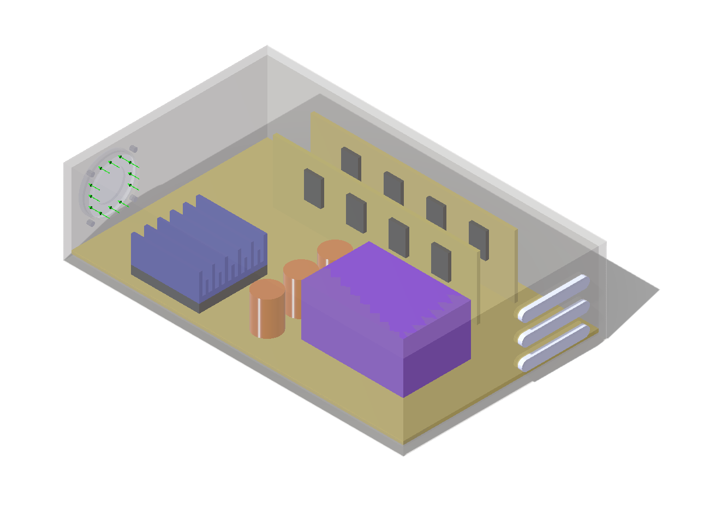
Figure 16. Case 03 external outlet fan geometry. Image file: case03_geometry.png
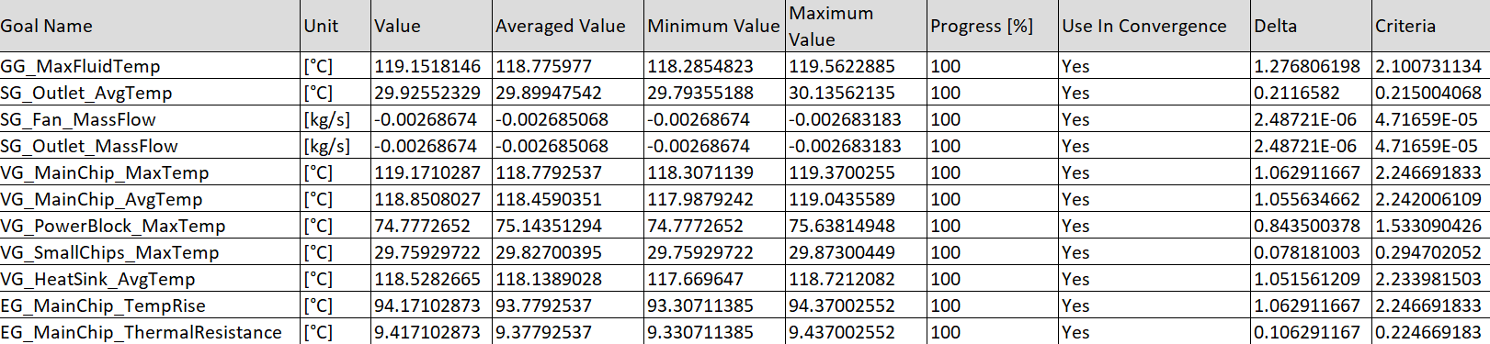
Figure 17. Case 03 goal table showing high chip temperature. Image file: case03_external_outlet_fan_goal_table.png
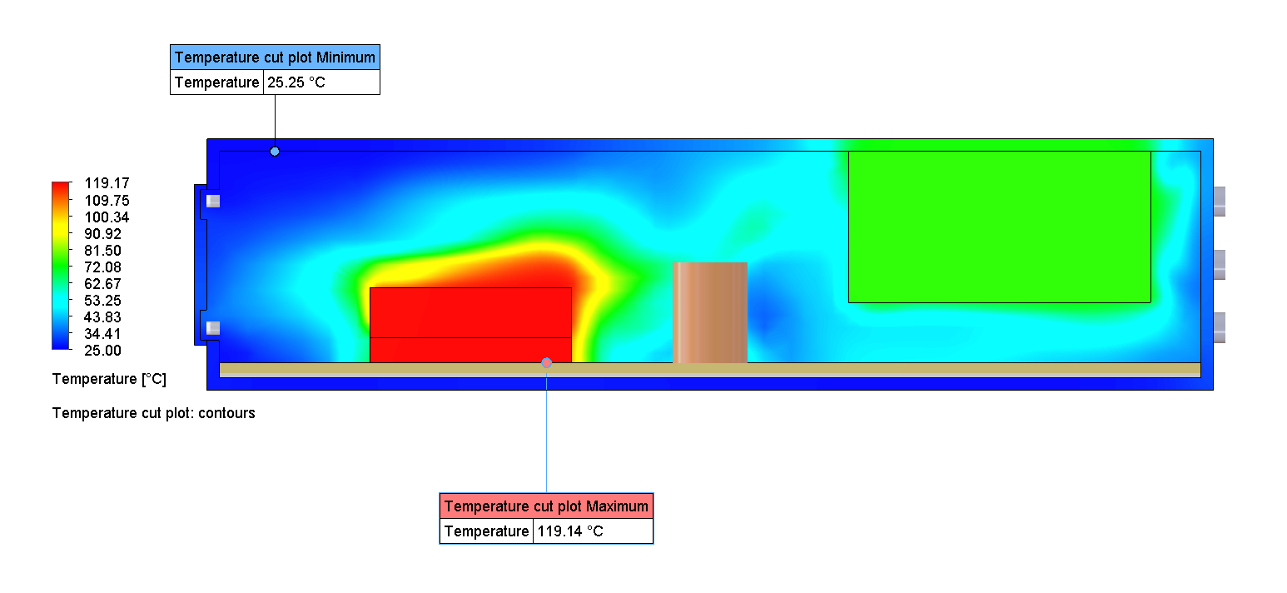
Figure 18. Case 03 temperature cut plot showing overheated chip and heat sink. Image file: case03_external_outlet_fan_temperature_cut.png
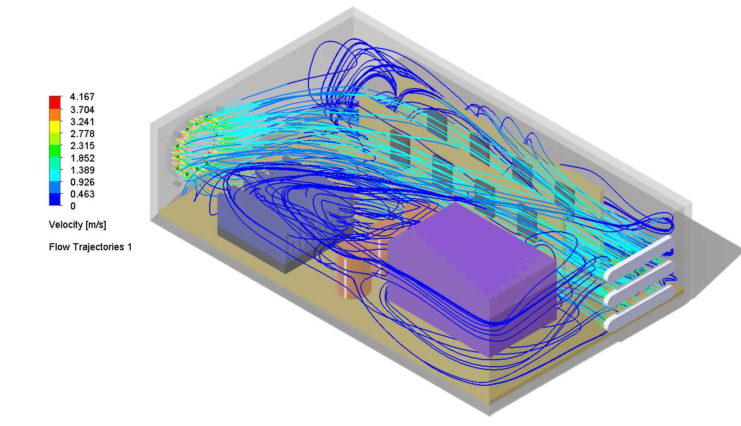
Figure 19. Case 03 flow trajectories showing ineffective heat sink cooling path. Image file: case03_external_outlet_fan_flow_trajectories.png

Case 04: Internal Fan, Low-Power Load
Case 04 modeled the fan as an internal fan with environmental pressure openings at the inlet side and outlet vents. This was selected as the more physically representative fan approach for future optimization.
Metric | Value
Main chip max temperature | 50.87 °C
Power block max temperature | 41.72 °C
Heat sink average temperature | 50.28 °C
Fan mass flow | +0.00294 kg/s
Decision | Selected fan approach for further optimization
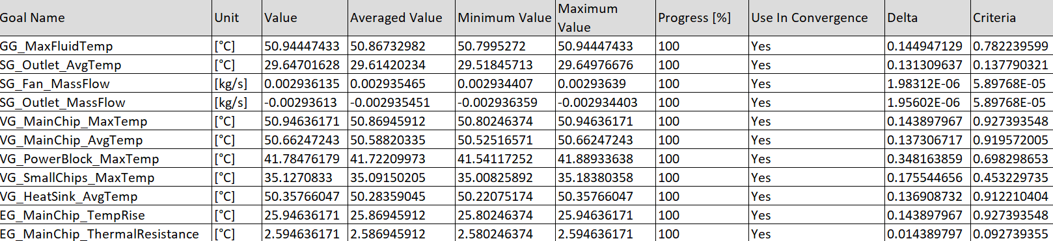
Figure 20. Case 04 goal table for internal fan low-power load. Image file: case04_internal_fan_goal_table.png
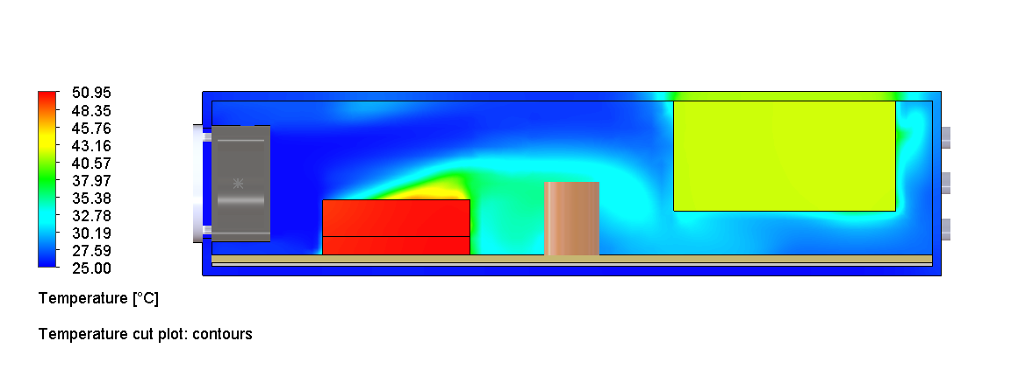
Figure 21. Case 04 temperature cut plot. Image file: case04_internal_fan_temperature_cut.png
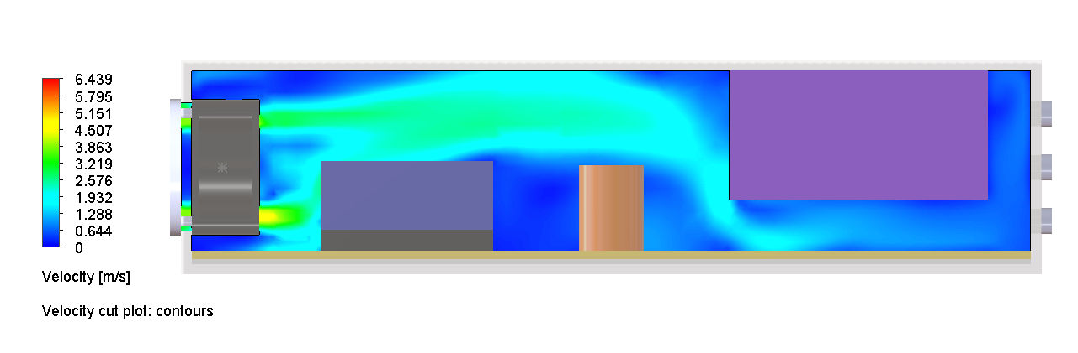
Figure 22. Case 04 velocity cut plot. Image file: case04_internal_fan_velocity_cut.png
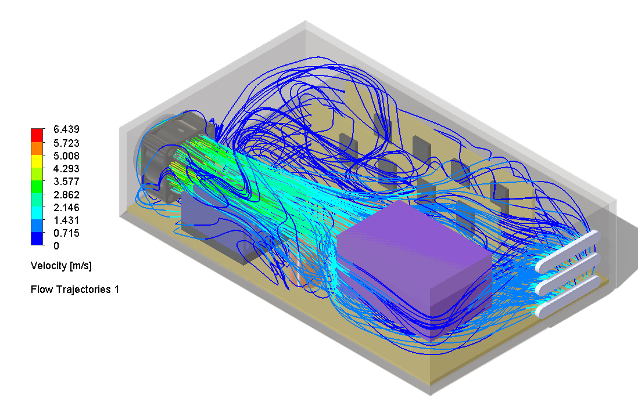
Figure 23. Case 04 flow trajectories. Image file: case04_internal_fan_flow_trajectories.png
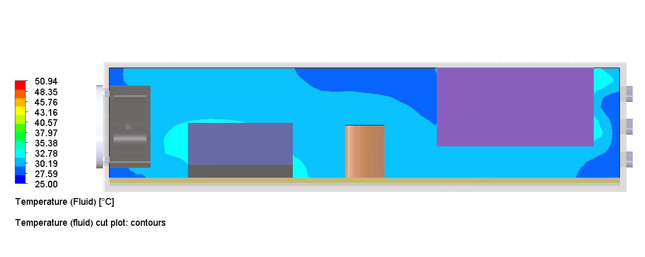
Figure 24. Case 04 fluid temperature cut plot. Image file: case04_internal_fan_fluid_temperature.png
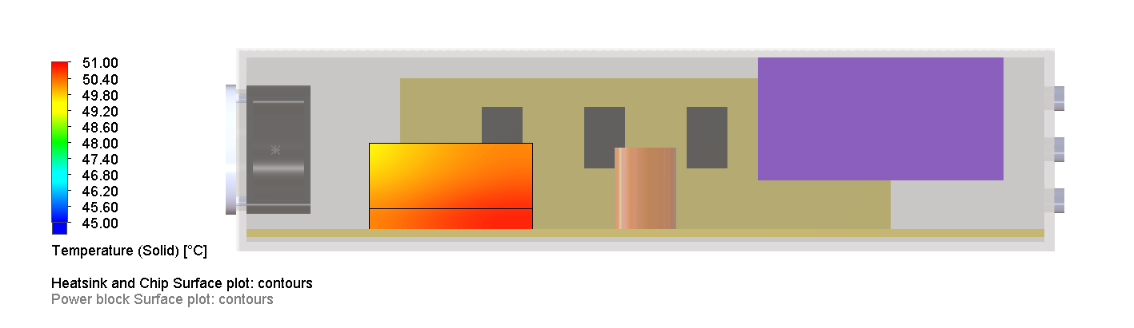
Figure 25. Case 04 chip and heat sink surface temperature. Image file: case04_internal_fan_chip_heatsink_surface_temp.png

Case 04B and Case 05: Higher-Power Stress and Top-Vent Learning Case
After selecting the internal fan approach, the heat load was increased to 25 W on the chip and 10 W on the power block. The internal fan alone was insufficient, reaching 99.80 °C on the main chip. A top vent reduced the chip temperature to 84.37 °C, but this was not selected as a preferred product direction because uncontrolled extra openings increase dust ingress risk.
Metric | Case 04B Internal Fan, 25 W | Case 05 Internal Fan + Upper Vent
Main chip max temperature | 99.80 °C | 84.37 °C
Power block max temperature | 65.15 °C | 55.25 °C
Heat sink average temperature | 98.16 °C | 82.98 °C
Decision | Too hot for chip | Thermally good, not preferred due dust risk
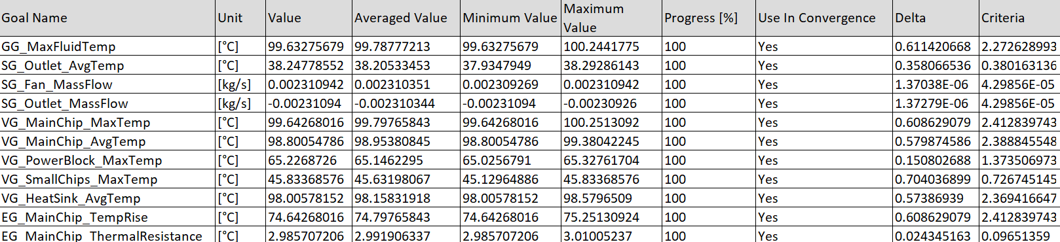
Figure 26. Case 04B goal table for 25 W chip stress load. Image file: case04b_internal_fan_25Wchip_10Wpower_goal_table.png
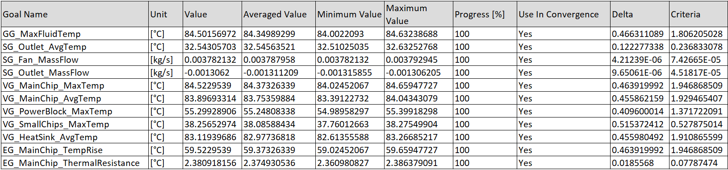
Figure 27. Case 05 goal table for internal fan with upper vent. Image file: case05_internal_fan_Upper_vent_goal_table.png
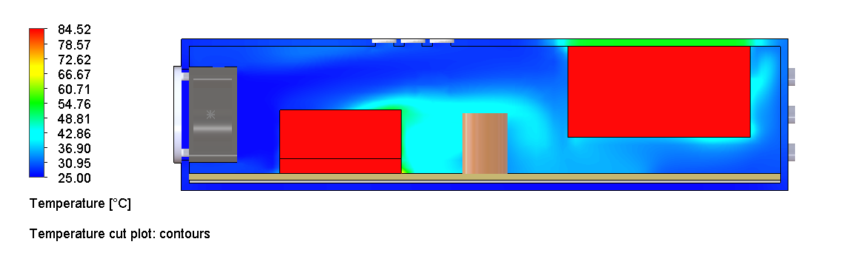
Figure 28. Case 05 temperature cut plot with upper vent. Image file: case05_internal_fan_Upper_vent_temperature_cut.png
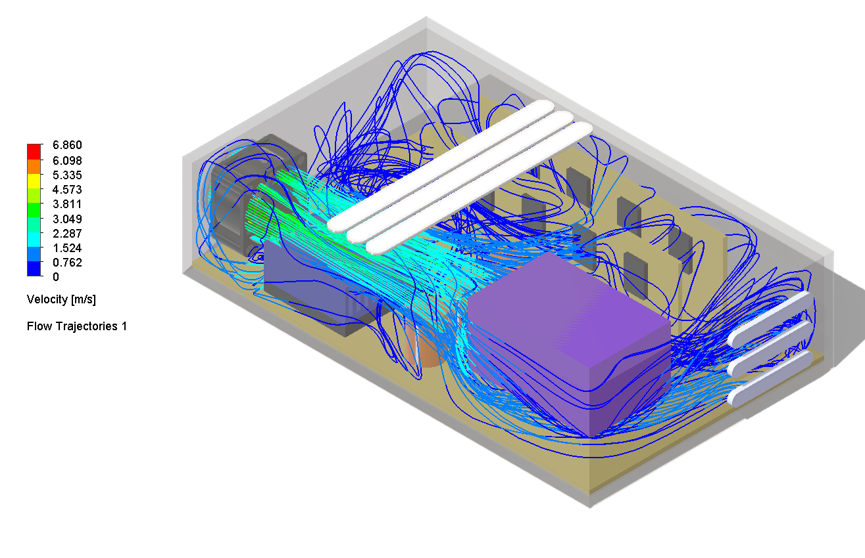
Figure 29. Case 05 flow trajectories with upper vent. Image file: case05_internal_fan_upper_vent_trajectories.png

Case 06: Internal Fan with Rear Exhaust Fan
Case 06 added a rear exhaust fan at the existing outlet side. This did not improve the main chip temperature. The exhaust fan altered the flow path and increased the main chip temperature to 95.40 °C while only slightly improving the power block temperature.
Metric | Value
Main chip max temperature | 95.40 °C
Power block max temperature | 58.48 °C
Heat sink average temperature | 93.90 °C
Decision | Rejected: rear exhaust fan worsened chip cooling
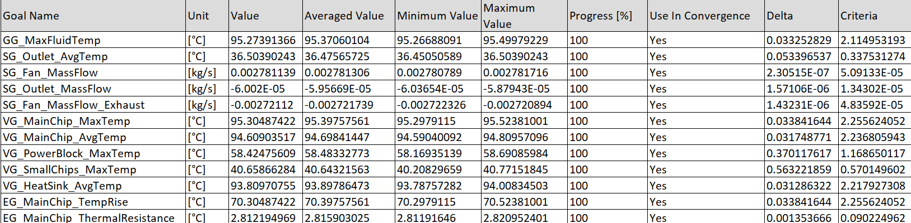
Figure 30. Case 06 goal table for rear exhaust fan case. Image file: case06_internal_fan_rear_exhaust_goal_table.png
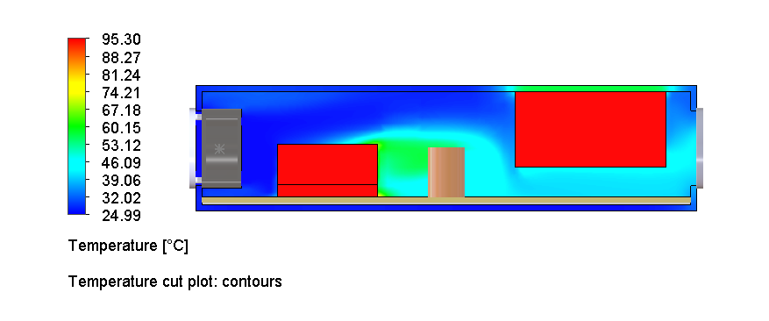
Figure 31. Case 06 temperature cut plot. Image file: case06_internal_fan_rear_exhaust_temperature_cut.png
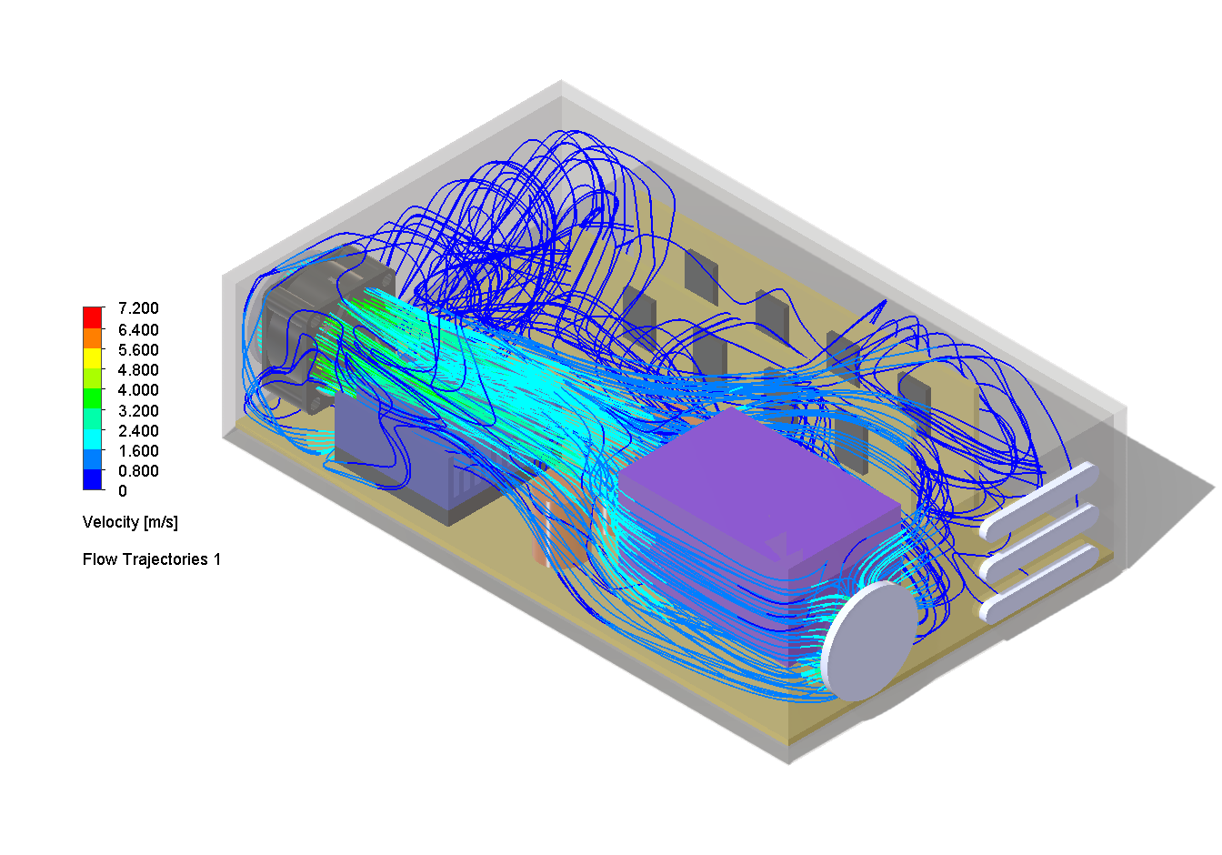
Figure 32. Case 06 flow trajectories showing bypass-dominated behavior. Image file: case06_internal_fan_rear_exhaust_flow_trajectories.png

Case 07: Optimized Aluminum Heat Sink
Case 07 used an optimized aluminum heat sink with a 50 x 50 mm footprint, 40 mm height, 1 mm fins, 14 fins, 3.3 mm gaps, and a 3.5 mm base. The heat sink solved the main chip problem but redirected the thermal bottleneck to the power block.
Metric | Value
Main chip max temperature | 50.89 °C
Power block max temperature | 84.10 °C
Heat sink average temperature | 48.12 °C
Decision | Excellent chip cooling, but power block became limiting
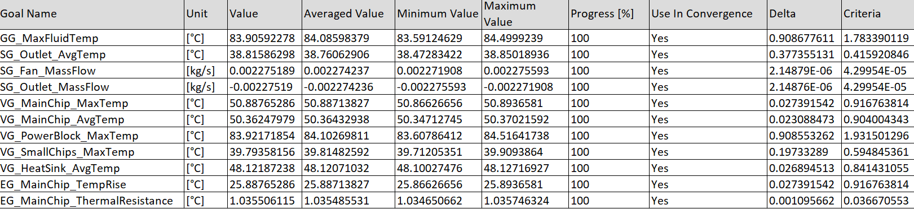
Figure 33. Case 07 goal table for optimized aluminum heat sink. Image file: case07a_internal_fan_25Wchip_10Wpower__new_HS_goal_table.png
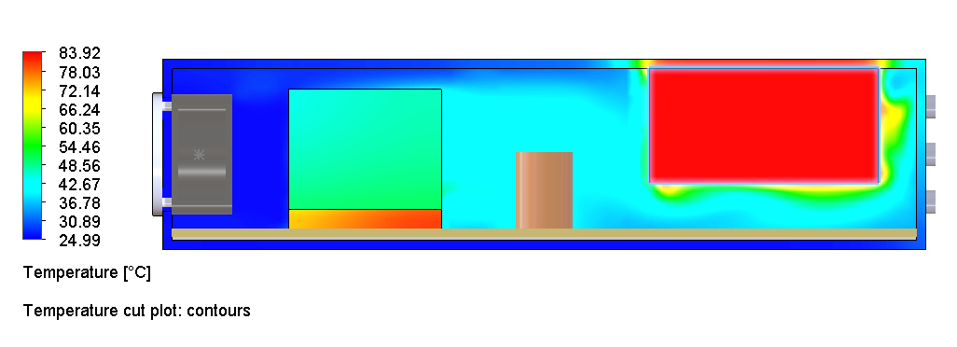
Figure 34. Case 07 temperature cut plot showing strong chip cooling and power block issue. Image file: case07_optimized_al_hs_temperature_cut.png
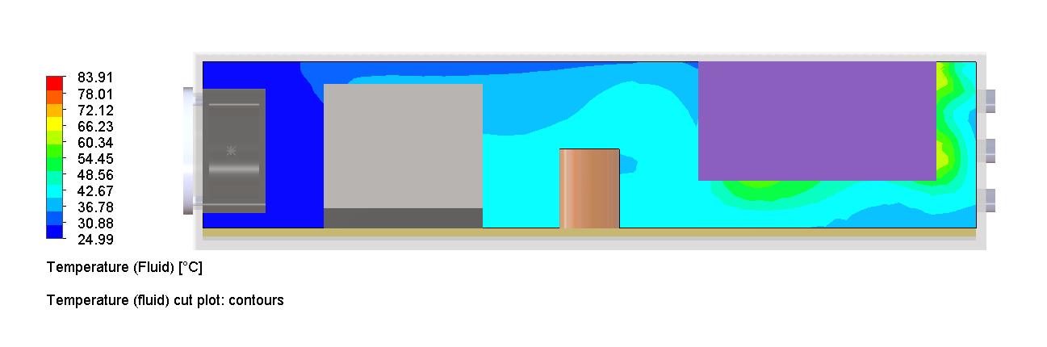
Figure 35. Case 07 velocity cut plot. Image file: case07_optimized_al_hs_velocity_cut.png
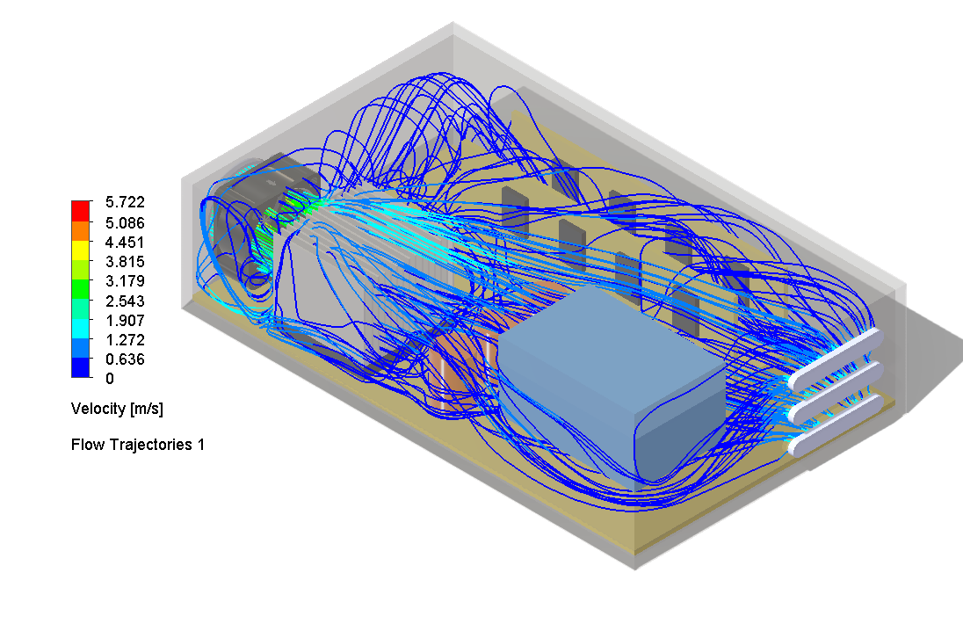
Figure 36. Case 07 flow trajectories. Image file: case07_optimized_al_hs_flow_trajectories.png

Case 08: Final Balanced Design - Optimized Heat Sink with Cross-Flow Inlet Fan
Case 08 added a side-mounted external inlet fan near the power block while retaining the optimized aluminum heat sink. This design gave up some excess chip cooling but solved the power block hot spot. It is the best balanced design in the study.
Metric | Value
Main chip max temperature | 61.07 °C
Power block max temperature | 59.96 °C
Heat sink average temperature | 58.00 °C
Small chips max temperature | 38.44 °C
Maximum fluid temperature | 61.07 °C
Outlet mass flow | -0.00390 kg/s
Decision | Selected final balanced configuration

Figure 37. Case 08 final design geometry with optimized heat sink and cross-flow inlet fan. Image file: case08_cross_fan_geometry.png
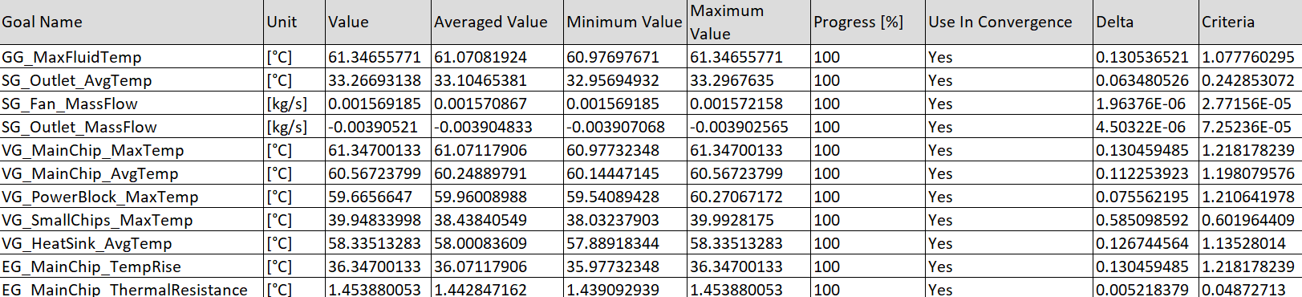
Figure 38. Case 08 goal table showing balanced chip and power block temperatures. Image file: case08_cross_fan_goal_table.png
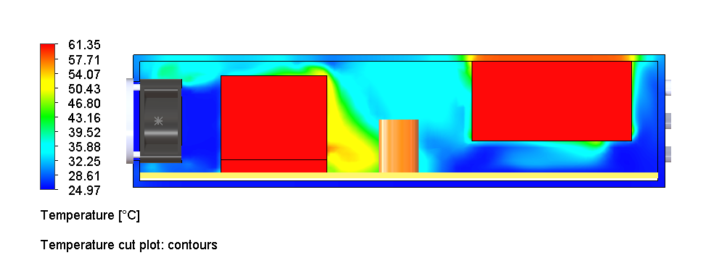
Figure 39. Case 08 temperature cut plot. Image file: case08_cross_fan_temperature_cut.png
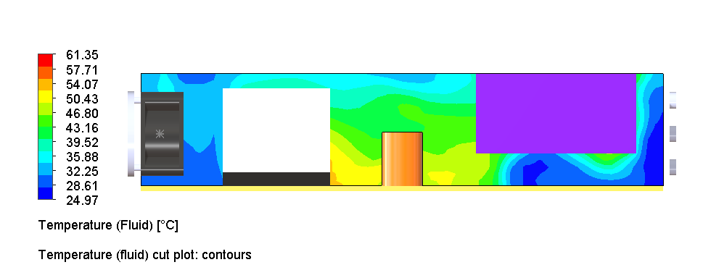
Figure 40. Case 08 fluid temperature cut plot. Image file: case08_cross_fan_fluid_temp_cut.png
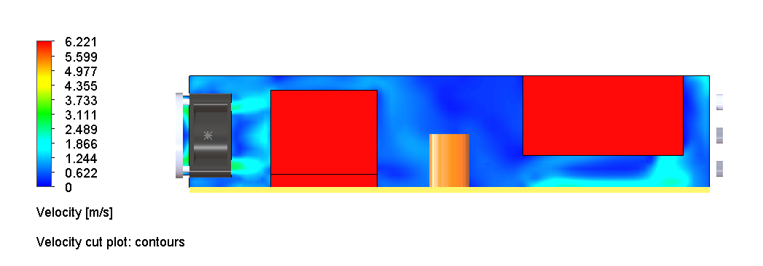
Figure 41. Case 08 velocity cut plot. Image file: case08_cross_fan_velocity_cut.png
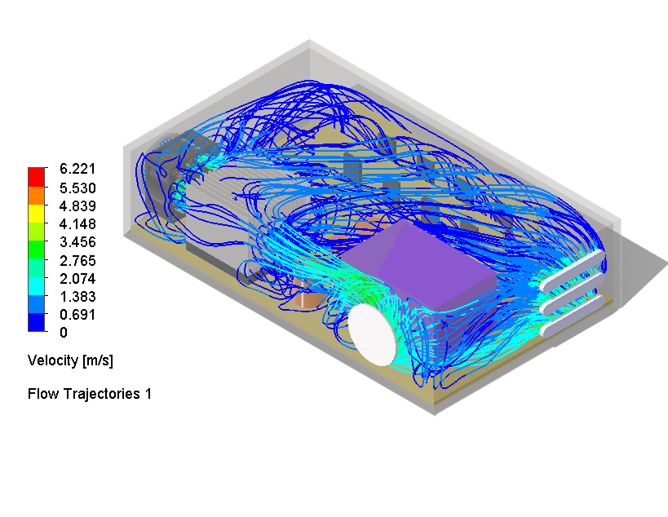
Figure 42. Case 08 flow trajectories showing cross-flow fan contribution. Image file: case08_cross_fan_flow_trajectories.png

4. Final Design Decision
The selected final design is Case 08: optimized aluminum heat sink with side-mounted cross-flow external inlet fan. This configuration balanced the two dominant heat sources under the 25 W chip / 10 W power block condition. Compared with Case 07, the main chip temperature increased from 50.89 °C to 61.07 °C, but the power block temperature dropped from 84.10 °C to 59.96 °C. This tradeoff is favorable because both components remain safely below the 85 °C target.
Design Objective | Final Status
Main chip below 85 °C | Pass: 61.07 °C
Power block below 70 °C preferred | Pass: 59.96 °C
Avoid uncontrolled dust-prone top openings | Pass: top vent was not selected
Avoid ineffective rear exhaust configuration | Pass: rear exhaust fan rejected
Maintain balanced enclosure cooling | Pass: chip, power block, and small chips all controlled

Final engineering conclusion
The optimized heat sink was necessary to control the 25 W main chip load, but it created a secondary hot spot at the power block. The side-mounted cross-flow inlet fan solved that secondary issue by directly supplying fresh air to the power block region and improving overall enclosure flow. The final design is therefore selected as the best balanced architecture from the tested cases.

5. Limitations
- Thermal contact resistance was simplified. Interfaces were treated as ideal or simplified contacts unless otherwise defined.
- PCB copper layers and detailed package construction were simplified. The boards were modeled primarily as FR-4.
- Fan behavior was based on SolidWorks fan curve definitions rather than physical fan testing.
- Radiation was neglected. This is acceptable for the relative comparison but can be added later for more complete modeling.
- No formal mesh independence study was completed. A future report revision should include coarse, medium, and fine mesh comparisons for the final case.
- Dust ingress, acoustic noise, manufacturability, filter pressure drop, EMI shielding, and serviceability were considered qualitatively but not fully modeled.
- The TEC concept was not simulated because the current limitation is air-side heat rejection, and a TEC would add electrical heat to the hot side.

6. Future Optimization for Higher Wattage
The final optimized design is suitable for the tested 25 W chip / 10 W power block condition. For higher-wattage electronics, additional thermal improvements would be needed. Future work should focus on increasing useful heat rejection area, improving heat spreading, and maintaining dust-controlled airflow.
Future Option | What it improves | Why it helps
Higher static pressure fan | Air-side convection through the heat sink | Improves flow through fin channels without adding passive dust-prone vents
Dedicated power block heat sink | Power block local heat rejection | Reduces dependence on airflow alone for the secondary hot component
Heat pipe to remote fin stack | Heat spreading and remote heat rejection | Moves chip heat to a region with better available airflow or more fin volume
Vapor chamber or copper spreader | Chip heat spreading | Reduces local hot spots before heat enters the fin stack
Filtered intake and controlled exhaust path | Dust-controlled airflow | Allows more airflow without uncontrolled open slots
Push-pull fan architecture | System through-flow | Can increase pressure capability if flow path is controlled
TEC feasibility study | Sub-ambient or precise temperature control | Only useful if hot-side heat rejection is upgraded; otherwise it adds heat to the system
A TEC should not be the next default optimization because the hot side must reject the chip heat plus the TEC electrical input power. For this assembly, the simulations show that air-side heat rejection and airflow distribution are the dominant constraints. Heat pipes, vapor chambers, stronger fans, or a dedicated power block heat sink are more efficient future directions for higher wattage.

7. Image Reference Appendix
The table below lists each figure and the exact source image file name used in the report.
Figure | Image file name | Description
1 | case08_cross_fan_geometry.png | Final optimized design geometry with optimized heat sink and cross-flow fan.
2 | case01_baseline_geometry.png | Case 01 baseline assembly geometry.
3 | case01_baseline_goal_table.png | Case 01 goal table with convergence and averaged values.
4 | case01_baseline_temperature_cut.png | Case 01 temperature cut plot showing the main chip and heat sink hot region.
5 | case01_baseline_velocity_cut.png | Case 01 velocity cut plot showing inlet flow and low-velocity regions.
6 | case01_baseline_flow_trajectories.png | Case 01 flow trajectories showing 3D airflow path from the fan.
7 | case01_baseline_heat_flow_budget.png | Case 01 heat flow budget from main chip into heat sink and fluid.
8 | case01_baseline_fluid_temperature.png | Case 01 fluid temperature cut plot.
9 | case02_reducer_shroud_geometry.png | Case 02 geometry with reducer shroud.
10 | case02_reducer_shroud_goal_table.png | Case 02 goal table with improved chip temperature.
11 | case02_reducer_shroud_temperature_cut.png | Case 02 temperature cut plot.
12 | case02_reducer_shroud_velocity_cut.png | Case 02 velocity cut plot showing guided airflow.
13 | case02_reducer_shroud_flow_trajectories.png | Case 02 flow trajectories with reducer shroud.
14 | case02_reducer_shroud_heat_flow_budget.png | Case 02 heat flow budget showing increased chip-to-heat-sink transfer.
15 | case02_reducer_shroud_fluid_temperature.png | Case 02 fluid temperature cut plot.
16 | case03_geometry.png | Case 03 external outlet fan geometry.
17 | case03_external_outlet_fan_goal_table.png | Case 03 goal table showing high chip temperature.
18 | case03_external_outlet_fan_temperature_cut.png | Case 03 temperature cut plot showing overheated chip and heat sink.
19 | case03_external_outlet_fan_flow_trajectories.png | Case 03 flow trajectories showing ineffective heat sink cooling path.
20 | case04_internal_fan_goal_table.png | Case 04 goal table for internal fan low-power load.
21 | case04_internal_fan_temperature_cut.png | Case 04 temperature cut plot.
22 | case04_internal_fan_velocity_cut.png | Case 04 velocity cut plot.
23 | case04_internal_fan_flow_trajectories.png | Case 04 flow trajectories.
24 | case04_internal_fan_fluid_temperature.png | Case 04 fluid temperature cut plot.
25 | case04_internal_fan_chip_heatsink_surface_temp.png | Case 04 chip and heat sink surface temperature.
26 | case04b_internal_fan_25Wchip_10Wpower_goal_table.png | Case 04B goal table for 25 W chip stress load.
27 | case05_internal_fan_Upper_vent_goal_table.png | Case 05 goal table for internal fan with upper vent.
28 | case05_internal_fan_Upper_vent_temperature_cut.png | Case 05 temperature cut plot with upper vent.
29 | case05_internal_fan_upper_vent_trajectories.png | Case 05 flow trajectories with upper vent.
30 | case06_internal_fan_rear_exhaust_goal_table.png | Case 06 goal table for rear exhaust fan case.
31 | case06_internal_fan_rear_exhaust_temperature_cut.png | Case 06 temperature cut plot.
32 | case06_internal_fan_rear_exhaust_flow_trajectories.png | Case 06 flow trajectories showing bypass-dominated behavior.
33 | case07a_internal_fan_25Wchip_10Wpower__new_HS_goal_table.png | Case 07 goal table for optimized aluminum heat sink.
34 | case07_optimized_al_hs_temperature_cut.png | Case 07 temperature cut plot showing strong chip cooling and power block issue.
35 | case07_optimized_al_hs_velocity_cut.png | Case 07 velocity cut plot.
36 | case07_optimized_al_hs_flow_trajectories.png | Case 07 flow trajectories.
37 | case08_cross_fan_geometry.png | Case 08 final design geometry with optimized heat sink and cross-flow inlet fan.
38 | case08_cross_fan_goal_table.png | Case 08 goal table showing balanced chip and power block temperatures.
39 | case08_cross_fan_temperature_cut.png | Case 08 temperature cut plot.
40 | case08_cross_fan_fluid_temp_cut.png | Case 08 fluid temperature cut plot.
41 | case08_cross_fan_velocity_cut.png | Case 08 velocity cut plot.
42 | case08_cross_fan_flow_trajectories.png | Case 08 flow trajectories showing cross-flow fan contribution.

